**STM ASSEMBLY – CHECK LIST**

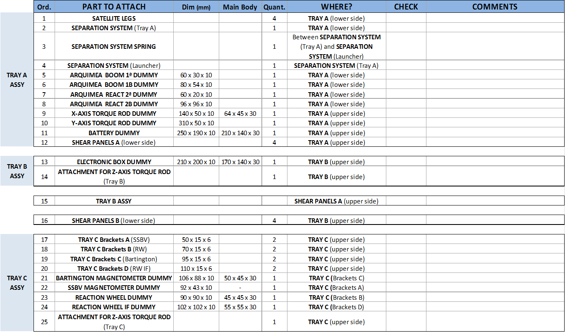



**STM ASSEMBLY – FIXING ELEMENTS CHECK LIST**

